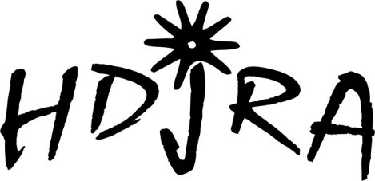

I, the undersigned, fully understand that in the conduct of this event there are numerous circumstances which could cause personal injury to me and others. Understanding that participation in this event has those risks, I hereby agree to release the High Desert Jr Rodeo Association, the Cassia County Fairgrounds, its agents and employees from any all claims or causes of action which might arise from this event. I also agree to abide by the rules of High Desert Jr Rodeo Association for this event, and permission is granted for the High Desert Rodeo Association and its affiliates the right to photograph and use my likeness for publicity purposes.

Dated this _____________ Day Of______________________,

2025 Applicant Signature _________________________________________

Applicants Printed Name____________________________________

Applicants Address____________________________________________

____________________________________________

Applicants Phone #____________________

Applicants date of Birth________________

We, the undersigned, grant permission to our son or daughter to participate in the above listed event, and in doing so, release High Desert Jr Rodeo and their assigns or any individual, from responsibility of liability for personal injury, loss or damage to private property incurred by or to the above named participant while taking part in the above named events.

Being Duly Sworn upon oath deposes and says this statement is true.

Parent or Guardian Signature________________________________________

Subscribed and sworn before me this _________Day of __________, 2025 in the state of______________, County of_______________________________,

My Commission Expires______________________,

Public Notary:_____________________________________